##### 2024-2027 SOR Community implementation ITA

North Dakota State Opioid Response (SOR) Grant

**Community Implementation**

Invitation to apply (ITA)

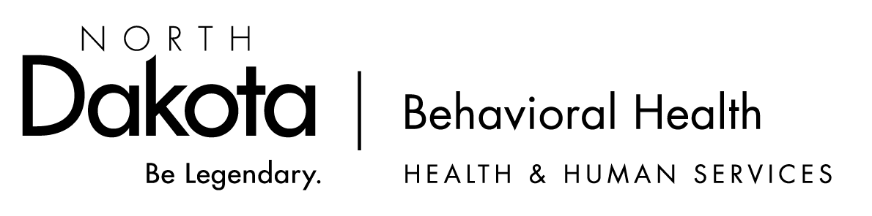

# Contents

Funding Opportunity Description 3

Eligible Applicants 3

Program Background and Goals of Program 3

Contract Dates 3

Expectations/Scope of Work 3

Funding Availability and Distribution 5

ITA Submission Information 5

Deadline for ITA Submission 5

Review Process 5

BHD Contact Information 5

Invitation to Apply (ITA) – Guidance 6

Invitation to Apply (ITA) - Form 8

# Funding Opportunity Description

## Eligible Applicants

Invitation to Apply (ITA) forms will be accepted from North Dakota Local Public Health Units (LPHUs).

## Program Background and Goals of Program

The State Opioid Response (SOR) program aims to address the opioid crisis by increasing access to medication-assisted treatment using the three FDA-approved medications for the treatment of opioid use disorder (MOUD), and for supporting the continuum of prevention, harm reduction, treatment, and recovery support services for opioid use disorder (OUD) and other concurrent substance use disorders. The SOR program also supports the continuum of care for stimulant misuse and use disorders, including for cocaine and methamphetamine. The SOR program aims to help reduce unmet treatment needs and opioid-related overdose deaths across America.

**North Dakota SOR Program Goals:**

1. Prevent substance (mis)use (specifically focused on opioids and stimulants).
2. Reduce harm related to opioids and stimulants.
3. Improve access to evidence-based treatment.
4. Increase access to recovery support services.

The purpose of this Community Implementation ITA is to support communities across the state to address local needs and gaps throughout the continuum of care specific to the opioid crisis, while also addressing stimulant misuse and use disorders.

## Contract Dates

The contract will run from September 30, 2024 to September 29, 2027. This will be contingent upon BHD receiving continued SOR funding annually.

## Expectations/Scope of Work

Vendor shall provide services in a manner that is recovery-oriented, trauma-informed, and person-centered.

Learn more with the following links:

* [Trauma-Informed](https://www.hhs.nd.gov/sites/www/files/documents/BH/Trauma%20Informed%20.pdf)
* [Recovery-Oriented](https://www.hhs.nd.gov/sites/www/files/documents/BH/Recovery-Oriented%20Systems.pdf)
* [Person-Centered](https://www.hhs.nd.gov/sites/www/files/documents/BH/Person%20Centered%20Care%20.pdf)
* [Integrated](https://www.hhs.nd.gov/sites/www/files/documents/BH/Integrated%20Care%20.pdf)

Vendor shall implement evidence-based strategies addressing opioid or stimulant misuse and use disorders through prevention, harm reduction, treatment, and recovery as identified in the submitted “Invitation to Apply”, as approved by the STATE.

Vendor shall implement the following strategies:

1. Increase access to naloxone through naloxone distribution with a focus on reaching individuals at high risk of experiencing an overdose.
2. Reduce opioid overdose related deaths by providing training on the recognition of opioid overdose and appropriate use of naloxone.
3. Reduce stigma surrounding Opioid Use Disorder (OUD) and the use of naloxone through the state opioid media campaign (Opioids: Fill with Care).
4. Increase access to naloxone by increasing awareness of where naloxone can be obtained.

Vendor shall ensure any organization provided SOR funding perform HIV and viral hepatitis testing as clinically indicated and referral to appropriate treatment provided to those testing positive. Vaccination for hepatitis A and B should be provided or referral made for same as clinically indicated.

Vendor shall utilize third party and other revenue realized from the provision of services to the extent possible and use SAMHSA funds only for services to individuals who are not covered by public or commercial health insurance programs, individuals for whom coverage has been formally determined to be unaffordable, or for services that are not sufficiently covered by an individual’s health insurance plan.

Vendor shall ensure no duplication of funding for activities being implemented. This includes but is not limited to the use of local and state opioid settlement funds and other local, state, and federal funding.

Vendor shall make any necessary project modifications as deemed necessary by STATE.

Vendor shall coordinate with all STATE-funded SOR sub-recipients to support collective efforts meeting the goals and objectives of the SOR program.

Vendor shall coordinate with existing community-based organizations and programs to maximize benefit, avoid duplication and leverage, redirect, and realign resources.

Vendor shall collaborate with STATE-contracted SOR evaluator to ensure all state and federal required data is collected, including the designated measures under the Government Performance and Results (GPRA) Modernization Act of 2010 for approved treatment and recovery activities (pre, follow-up, and post-activities).

Vendor shall comply with reporting deadlines as required by the Substance Abuse and Mental Health Services Administration (SAMHSA).

Vendor shall submit monthly reports to STATE by the 10th of each month (unless otherwise directed based on SAMHSA requirements), which may include project performance, implementation status, achievement and barriers, any changes to local strategy implementation, process and outcome measures, and other measures as identified by SAMHSA or STATE

Vendor shall engage in ongoing communication with STATE and project evaluator for monitoring of local strategy implementation and project analysis.

By September 15, 2025 and September 15, 2026, Vendor shall complete a Continuation of Funding form to include:

* Summary of progress made for each implemented strategy, including success stories.
* Identified barriers to implementation for each strategy and efforts made to address them.
* Continued funding needs

By September 15, 2027, Vendor shall complete a project summary report to include the following information:

* Summary of progress made for each implemented strategy, including success stories.
* Identified barriers to implementation for each strategy and efforts made to address them.

Vendor shall participate in training and technical assistance provided by STATE.

Vendor shall follow all SAMHSA standard funding restrictions.

Vendor shall ensure all communication (i.e. media, partnership meetings, stakeholders, etc.) about efforts related to this project includes the following language:

* *This effort is associated with North Dakota’s State Opioid Response Grant (SOR), funded by the federal Department of Health and Human Services (DHHS), Substance Abuse and Mental Health Services Administration (SAMHSA), administered through the North Dakota Department of Health and Human Services, Behavioral Health Division.*

## Funding Availability and Distribution

Total available funding for Community Implementation is approximately **$1,800,000 per year**. This funding is contingent upon North Dakota being awarded the State Opioid Response (SOR) grant from SAMHSA. As of 8/19/2024, BHD has not received an official award but anticipates receiving an award.

Distribution of funding will be based on the identified needs of each community and how well strategy implementation will meet the needs of each community.

# ITA Submission Information

## Deadline for ITA Submission

Applicants must submit completed *Invitation to Apply (ITA)* form by **September 18, 2024** to Amy Lies at [amlies@nd.gov](mailto:amlies@nd.gov). A response will be provided upon receipt of an ITA. If you do not receive a response within 2 business days, please reach out to Amy Lies.

|  |  |  |
| --- | --- | --- |
| **Schedule** | **Dates** | **Time (CT)** |
| Invitation to Apply submission deadline | September 18, 2024 | 5:00PM |
| Approximate date of Notification of Award | September 30, 2024 |  |
| Contract start | September 30, 2024 |  |
| Contract end | September 29, 2027 |  |

## Review Process

Completed ITAs will be reviewed by the Behavioral Health Division. Allow up two weeks following the application deadline for notice of award.

# BHD Contact Information

Please contact Amy Lies with any questions.

Email: [amlies@nd.gov](mailto:amlies@nd.gov)

Phone: 701-328-8933

Main BHD office: 701-328-8920

# Invitation to Apply (ITA) – Guidance

In 2023, the Substance Abuse and Mental Health Services Administration (SAMHSA) released the *Opioid-Overdose Reduction Continuum of Care Approach (ORCCA) Practice Guide*. The guide includes a menu of evidence-based practices for reducing opioid overdose deaths and real-world tips for implementing the evidence-based practices. We encourage you to view the guide and utilize it to plan for implementation of strategies that address the needs in your community. Below are some highlighs from the guide. You can access the full guide here: [Opioid-Overdose Reduction Continuum of Care Approach (ORCCA) Practice Guide 2023 (samhsa.gov)](https://store.samhsa.gov/sites/default/files/pep23-06-01-001.pdf).

In 2023, SAMHSA also release the Engaging Community Coalitions to Decrease Opioid Overdose Deaths Practice Guide 2023. You can access the guide here: [Engaging Community Coalitions to Decrease Opioid Overdose Deaths Practice Guide 2023 (samhsa.gov)](https://store.samhsa.gov/sites/default/files/pep23-06-01-002.pdf).

|  |
| --- |
| **Tips for data-driven strategy selection** |

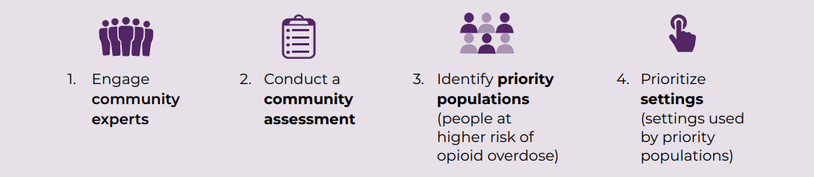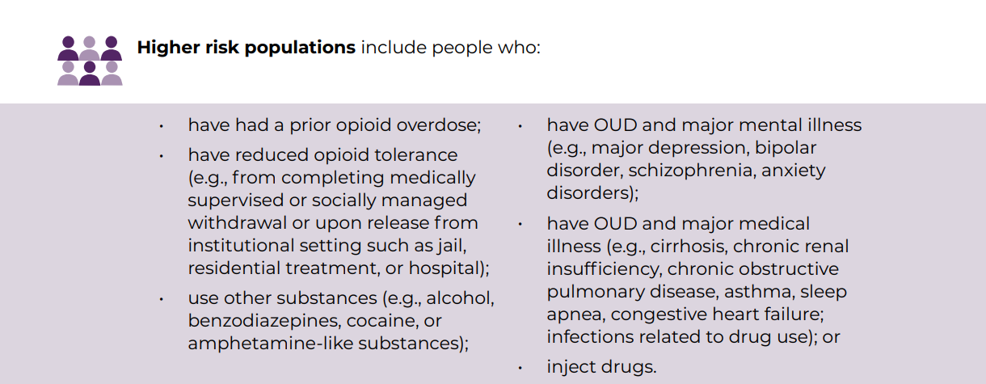

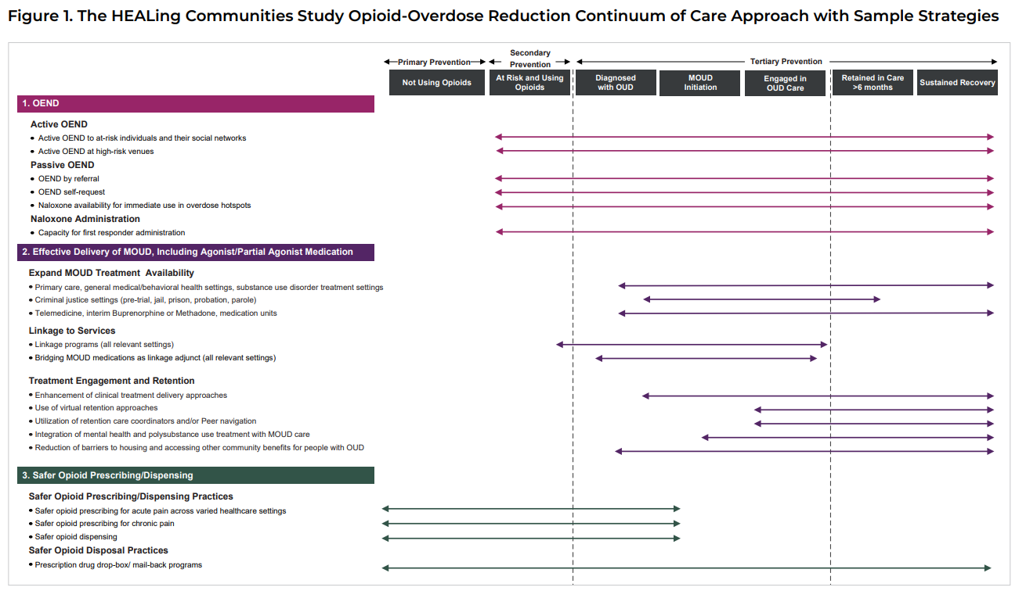

Invitation to Apply (ITA) - Form

|  |  |  |  |  |  |  |
| --- | --- | --- | --- | --- | --- | --- |
| **Contact Information** | | | | | | |
| Name of Local Public Health Unit | |  | | | | |
| Phone Number | |  | | | | |
| Address | | Physical |  | Mailing |  | |
| Community Implementation Coordinator | | Name |  | Email |  | |
| Community Implementation Fiscal contact | | Name |  | Email |  | |
| Other contact | | Title |  | Name |  | |
| Email |  | | | |
|  | | | | | | |
| **State Goal 1: Prevent opioid and stimulant (mis)use** | | | | | | |
| **Answer the following questions and use it to guide the selection of prevention strategy implementation.** | | | | | | |
| **What is your community doing well in terms of opioid or stimulant prescription medication safety? What safety concerns does you community have?** | | | | | | |
|  | | | | | | |
| **Does your community have a coalition? If so, what is the focus? If not, what are the barriers to having one?** | | | | | | |
|  | | | | | | |
| **What opportunities are available to implement prevention in your community including strategies to reach youth and young adults?** | | | | | | |
|  | | | | | | |
| **Planning and implementation** | | | | | | |
| **Select each strategy you plan to implement** | | | | | | **Amount of funding to implement strategy** |
|  | Promote medication safety by partnering with local law enforcement to host drug Take Back event(s), establish drug Take Back locations, and/or promote drug Take Back events and locations | | | | |  |
|  | Promote medication safety by distributing safe medication disposal products (DisposeRX and/or Deterra bags) *\*These products are supplied by BHD and do not need to be included in your funding request* | | | | |  |
|  | Increase prescription medication safety by facilitating academic detailing related to evidence-based prescribing practices and alternative pain management options (academic detailing is an evidence-based method focused on clinician education and behavior change) | | | | |  |
|  | Use evidence-based practices to increase knowledge of school-aged and/or transitional aged youth on the harms associated with opioids and stimulants, on safe medication practices, and on the dangers of counterfeit pills *\*BHD must review any curriculum or program prior to implementation* | | | | |  |
|  | Enhance community engagement through building and maintaining a community coalition focused on community health and wellness including decreasing opioid related deaths | | | | |  |
|  | Provide education on medication safety and harms associated with opioids through the state opioid media campaign (*“Opioids: Take Care, Be Aware”*) | | | | |  |
|  | *For vendors NOT receiving SUPTRS Prevention Block funds – Provide support to parents to create a safe environment for their children that promotes behavioral health while preventing substance use through the state opioid media campaign (*“Parents Lead”*) | | | | |  |
|  | Other: Please list - | | | | |  |

|  |  |
| --- | --- |
| **Total funding request to implement prevention strategies for 1 year** |  |

|  |  |  |  |  |  |  |
| --- | --- | --- | --- | --- | --- | --- |
| **Outline the action plan for implementation of each identified strategy from above** | | | | | | |
| Action step | | | Who | When | Process or outcome measure | |
|  | | |  |  |  | |
|  | | |  |  |  | |
|  | | |  |  |  | |
|  | | |  |  |  | |
|  | | |  |  |  | |
|  | | |  |  |  | |
|  | | |  |  |  | |
|  | | |  |  |  | |
|  | | |  |  |  | |
|  | | |  |  |  | |
|  | | |  |  |  | |
|  | | | | | | |
| **State Goal 2: Reduce harm related to opioids and stimulants** | | | | | | |
| **Answer the following questions and use it to guide the selection of harm reduction strategy implementation** | | | | | | |
| **What is the rate of opioid overdoses in your community and to whom is it happening to (e.g., age group, race/ethnicity, gender)?** | | | | | | |
|  | | | | | | |
| **Where are overdoses occurring (e.g., specific neighborhoods, public restrooms, at home)?** | | | | | | |
|  | | | | | | |
| **Are there existing programs in your community that could offer naloxone but don’t (e.g., jails, emergency departments, acute care settings, leave behind at sites of overdose, mental health and addiction treatment programs)**  **What are the barriers for these programs to offer naloxone?** | | | | | | |
|  | | | | | | |
| **How can you reach people at highest risk of experiencing an opioid overdose to provide opioid overdose prevention education and naloxone distribution?** | | | | | | |
|  | | | | | | |
| **Planning and implementation** | | | | | | |
| **Select each strategy you plan to implement** | | | | | | **Amount of funding to implement strategy** |
| **Required** | | Operate as an Opioid Overdose Prevention Education and Naloxone Distribution (OEND) program in your community. This includes:   1. Performing active OEND. Active OEND is proactive distribution of overdose prevention and response education and naloxone rescue kits to higher risk populations and their social networks. 2. Performing passive OEND. Passive OEND is overdose prevention and response education and naloxone rescue kit distribution to people referred by other care providers or for those seeking OEND on their own. 3. Increase awareness of where naloxone can be obtained | | | |  |
| **Required** | | Increase knowledge on signs and symptoms of an opioid, how to effectively respond to an opioid overdose, the dangers of counterfeit pills, and reduce stigma surrounding OUD and the use of naloxone through the state opioid media campaign (*“Opioids: Take Care, Be aware”*) | | | |  |
| *If the LPHU currently operates a Syringe Service Program:* | | | | | | |
|  | Increase availability of harm reduction supplies by purchasing and distributing fentanyl test strips | | | | |  |
|  | Increase availability of harm reduction supplies by purchasing and distributing xylazine test strips | | | | |  |
|  | Increase access to harm reduction supplies by purchasing and managing a harm reduction vending machine | | | | |  |
|  | Enhance existing harm reduction services | | | | |  |
|  | Reduce stigma related to harm reduction efforts through the state opioid medica campaign (“*Opioids: Take Care, Be Aware”)* | | | | |  |
|  | Other: Please list - | | | | |  |
| *If the LPHU does not currently operates a Syringe Service Program:* | | | | | | |
|  | Increase access to harm reduction services by establishing a Syringe Service Program | | | | |  |
|  | Increase access to harm reduction services by partnering with existing Syringe Service Programs | | | | |  |
|  | Other: Please list - | | | | |  |

|  |  |
| --- | --- |
| **Total funding request to implement harm reduction strategies for 1 year** |  |

|  |  |  |  |
| --- | --- | --- | --- |
| **Outline the action plan for implementation of each selected strategy from above** | | | |
| Action step | Who | When | Process or outcome measure |
| Perform active OEND |  |  |  |
| Perform passive OEND |  |  |  |
| Increase awareness of where naloxone can be obtained by: |  |  |  |
|  |  |  |  |
|  |  |  |  |
|  |  |  |  |
|  |  |  |  |
|  |  |  |  |
|  |  |  |  |

|  |  |  |
| --- | --- | --- |
| **State Goal 3: Improve access to evidence-based treatment** | | |
| **Answer the following questions and use it to guide the selection of treatment strategy implementation** | | |
| **What medication for opioid use disorder (MOUD) services already exist in your community? Is there a waiting list for these services? Is telehealth offered to access these services?** | | |
|  | | |
| **Where in your community could MOUD be provided but it isn’t (e.g., jails, emergency departments, primary care clinics)? What are the barriers for these entities to provide MOUD?** | | |
|  | | |
| **How can you reach people with OUD who are not receiving MOUD?** | | |
|  | | |
| **What the most significant barriers to individuals accessing MOUD?** | | |
|  | | |
| **Planning and implementation** | | |
| **Select each strategy you plan to implement** | | **Amount of funding to implement strategy** |
|  | Increase access to medications for opioid use disorder (MOUD) by partnering with an existing OTP to establish a medication unit |  |
|  | Increase access to MOUD be reducing financial barriers to receiving the medications \**This strategy requires GPRA collection* |  |
|  | Increase access to MOUD by facilitating academic detailing related to prescribing MOUD (academic detailing is an evidence-based method focused on clinician education and behavior change) |  |
|  | Increase access to MOUD by supporting MOUD inductions within an Emergency Department \**This strategy requires GPRA collection* |  |
|  | Increase access to MOUD for individuals who are incarcerated by supporting jails on the adoptions or enhancement of policies supportive of MOUD |  |
|  | Increase access to treatment for individuals who are incarcerated by linking SUD Voucher providers with local jails |  |
|  | Increase access to treatment by reducing barriers such as childcare (SOR is payor of last resort) |  |
|  | Educate the public on treatment options and reduce stigma surrounding MOUD through the state opioid media campaign (“*Take Care, Be Aware”)* |  |
|  | Other: Please list- |  |

|  |  |
| --- | --- |
| **Total funding request to implement treatment strategies for 1 year** |  |

|  |  |  |  |  |  |
| --- | --- | --- | --- | --- | --- |
| **Outline the action plan for implementation of each selected strategy from above** | | | | | |
| Action step | | Who | When | Process or outcome measure | |
|  | |  |  |  | |
|  | |  |  |  | |
|  | |  |  |  | |
|  | |  |  |  | |
|  | |  |  |  | |
|  | |  |  |  | |
|  | |  |  |  | |
|  | |  |  |  | |
|  | |  |  |  | |
|  | |  |  |  | |
|  | |  |  |  | |
|  | |  |  |  | |
|  | |  |  |  | |
|  | | | | | |
| **State Goal 4: Increase access to recovery support services** | | | | | |
| **Answer the following questions and use it to guide the selection of recovery strategy implementation** | | | | | |
| **What support services currently exist for persons in recovery from OUD and/or stimulant use order in your community?** | | | | | |
|  | | | | | |
| **What support services are most needed for persons in recovery from OUD and/or stimulant use disorder in your community?** | | | | | |
|  | | | | | |
| **How is Peer Support or Family Peer Support currently integrated into your community?** | | | | | |
|  | | | | | |
| **What are potential opportunities to integrate Peer Support into your community?** | | | | | |
|  | | | | | |
| **Planning and implementation** | | | | | |
| **Select each strategy you plan to implement** | | | | | **Amount of funding to implement strategy** |
|  | Increase availability of peer support services by supporting individuals to become Peer Support Specialists | | | |  |
|  | Increase availability of peer support services by contracting with or hiring a Peer Support Specialist \**This strategy requires GPRA collection* | | | |  |
|  | Increase availability of peer support services by supporting the adoption or enhancement of policies that integrate Peer Support Specialists into existing services. | | | |  |
|  | Increase access to recovery support services by reducing barriers such as transportation or childcare (SOR is payor of last resort) | | | |  |
|  | Support the adoption or enhancement of best practices within existing recovery services to ensure access for individuals receiving MOUD | | | |  |
|  | Reduce stigma surrounding OUD, Stimulant Use Disorder, and recovery through the state opioid media campaign (“*Opioids: Fill with Care”)* | | | |  |
|  | Other: Please list- | | | |  |

|  |  |
| --- | --- |
| **Funding request to implement recovery strategies for 1 year** |  |

|  |  |  |  |
| --- | --- | --- | --- |
| **Outline the action plan for implementation of each selected strategy from above** | | | |
| Action step | Who | When | Process or outcome measure |
|  |  |  |  |
|  |  |  |  |
|  |  |  |  |
|  |  |  |  |
|  |  |  |  |
|  |  |  |  |
|  |  |  |  |
|  |  |  |  |
|  |  |  |  |
|  |  |  |  |
|  |  |  |  |
|  | | | |

|  |  |
| --- | --- |
| **Total funding request to implement all strategies for 1 year** |  |

|  |  |  |
| --- | --- | --- |
| ------------------------------------------------------------------- | FOR BEHAVIORAL HEALTH DIVISION TO COMPLETE | -------------------------------------------------------------------- |

|  |  |
| --- | --- |
| Amount requested by LPHU |  |
| Amount awarded by BHD |  |

|  |
| --- |
| Comments |
|  |

|  |  |
| --- | --- |
| Signature of SOR Grant Coordinator |  |
| Date |  |